**WEDDING BELLS DFD**

Level 0 dfd for wedding bells

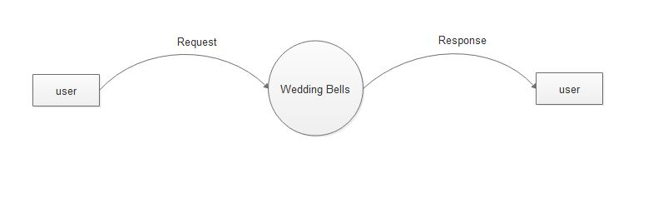

Level 1 dfd of Admin for wedding bells

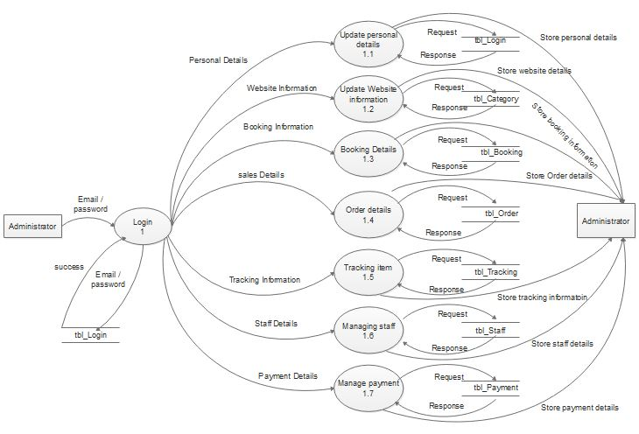

Level 1 dfd of staff for wedding bells

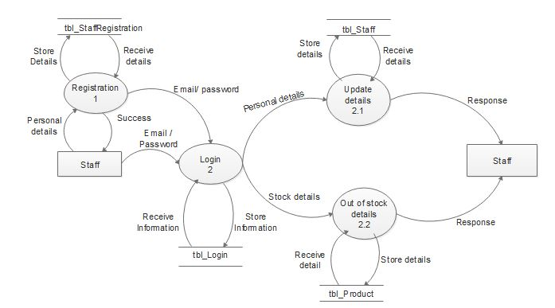

Level 1 dfd of customer for wedding bells

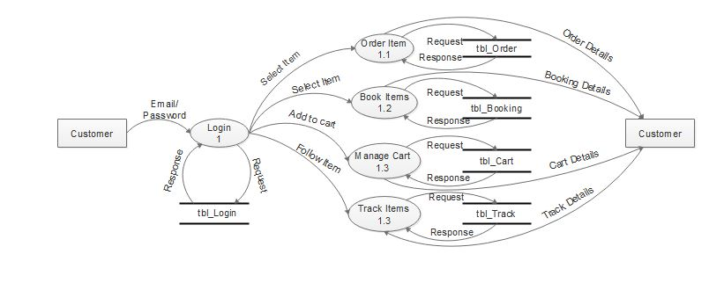

Level 2 dfd of customer for cart management

